**OverTheWire Bandit - Level 5 to Level 6 Writeup**

**Introduction**: This writeup documents my experience solving Levels 5 to 6 of the OverTheWire Bandit challenge, a CTF-style game focused on learning about security concepts.

**Author**: Misha Jain

**Date**: October 19, 2023

**Tools Used:**

Terminal (SSH client)

**Challenge Description:**

Level 5 to Level 6 of Bandit involves connecting to a remote server via SSH and retrieving the flag located in a specific file within the "inhere" directory. The challenge provides properties for the file we need to find.

**Enumeration:**

For Level 5, we need to connect to the server using the credentials we obtained in Level 4. Our goal is to find a file that is human-readable, 1033 bytes in size, and not executable, within the "inhere" directory.

**Exploitation - Level 5:**

To connect to the server for Level 5 using SSH, we use the provided credentials:

ssh bandit5@bandit.labs.overthewire.org -p 2220

Use the password obtained from Level 4, which is lrIWWI6bB37kxfiCQZqUdOIYfr6eEeqR to gain access.

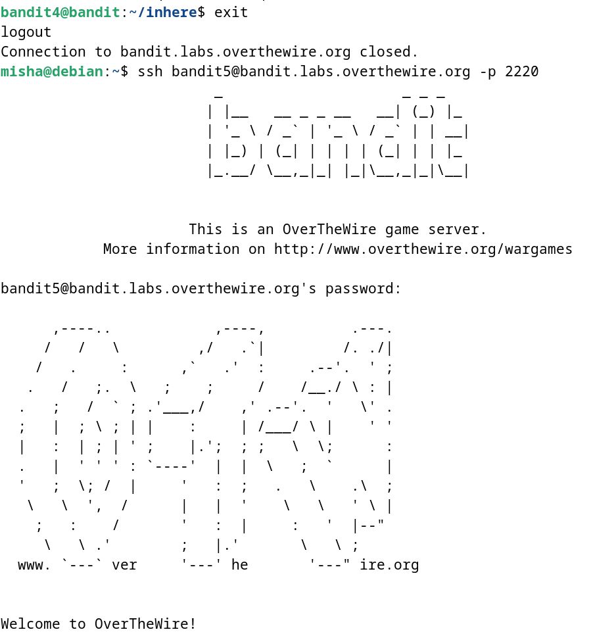

**Password Retrieval - Level 5:**

The password for Level 6 is stored in a file that meets certain properties in the "inhere" directory. To locate this file, we can use the find command with the provided criteria. We'll search for a file that is human-readable, 1033 bytes in size, and not executable:

ls -alps

cd inhere/

find . -type f -size 1033c ! -executable | xargs file

‘-size 1033c’ states that files must have a size of exactly 1033 bytes (the c indicates bytes).

‘! -executable’ states that the files should not be executable.

After using the find command, we get to know that ‘./maybehere07/.file02’ is the only file that meets the specifications. Hence, we use the cat command to access the contents of ./maybehere07/.file02.

cat ./maybehere07/.file02

These commands will display the Level 6 password.

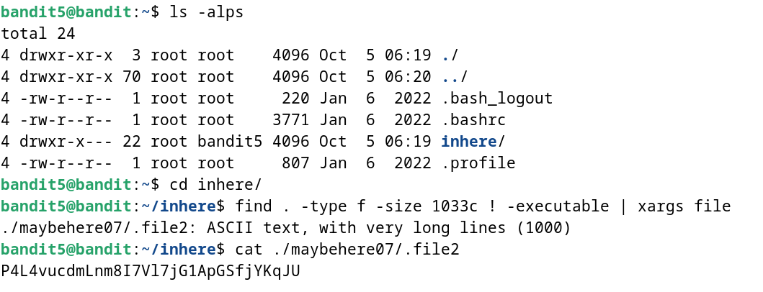

**Password – Level 6:**

The password for Level 6 is: P4L4vucdmLnm8I7Vl7jG1ApGSfjYKqJU

**Exploitation – Level 6:**

Now that we have the Level 6 password, we can connect to the server for Level 6 using SSH:

ssh bandit6@bandit.labs.overthewire.org -p 2220

Use the Level 6 password to gain access.

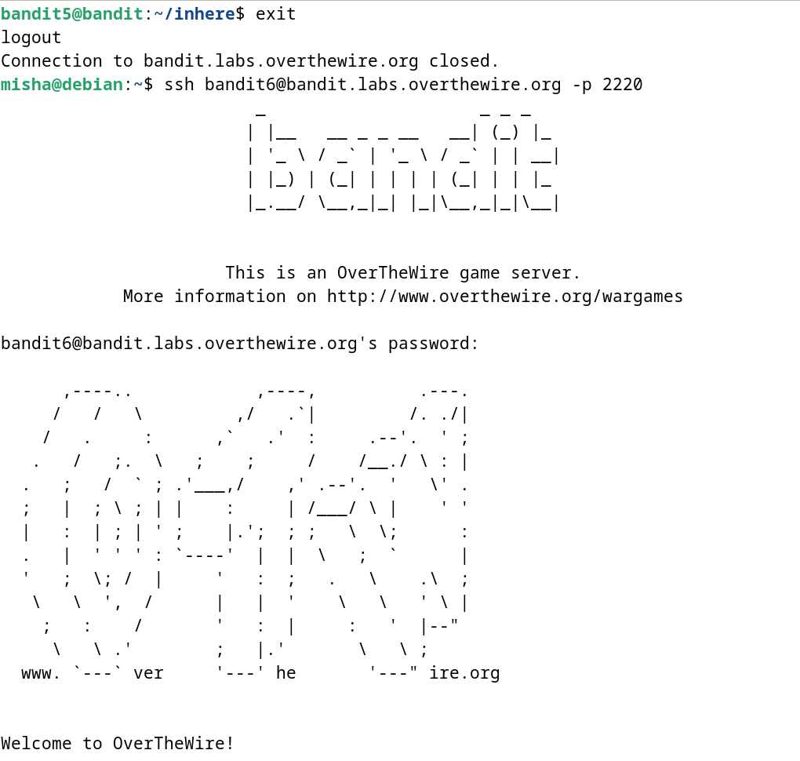

**Lessons Learned:** Level 5 to 6 introduced us to using the find command with various criteria to search for files that meet specific properties. This level reinforced the use of the cat command to read the contents of a file.

**Conclusion:**

Levels 5 to 6 of the OverTheWire Bandit challenge continue to build on shell command knowledge while introducing new challenges involving file properties and searching. These levels are suitable for beginners to learn more about working with files and directories.